**TEAM5OAGS**

**TEAM5OAGS RoR MVC Framework Seed Team Project**

***Version 2.0***

**Signature Block**

|  |  |  |
| --- | --- | --- |
| **COSC 4351** | **Name Signature** | **Date** |
| ***SE Team Leader*** | Ryan Lee |  |
| ***SQA*** | Christopher Cruz |  |
| ***SQA*** | Muhammad Naviwala |  |

# Document Control

Change History

**TLs entries (assigned work and due dates) before releasing to the team**

|  |  |  |  |
| --- | --- | --- | --- |
| Revision | Name | Due Date | Description |
| 1.X | Christopher Cruz SQA | 03/25/2013 | Create the seed project |
| 1.Y | Muhammad Naviwala SQA | 03/25/2013 | Create the seed project |

**TLs entry before BLUE TEAMS DELIVERABLES**

|  |  |  |  |
| --- | --- | --- | --- |
| Revision | Name | Due Date | Description |
| 1.0 | Ryan Lee – TL | 03/26/2013 | I changed Version to 2.0 |

Document Storage

This file is stored in **SVN** at [http://limi.cs.uh.edu/COSC4351/team**5**/TEAM](http://limi.cs.uh.edu/COSC4351/team5/TEAM) PROJECT DELIVERABLES/TEAM5OAGS RoR MVC Framework Seed Team Project.doc

**DO NOT CHANGE the name of the document!!!! It will stay TEAM5OAGS RoR MVC Framework Seed Team Project.doc!!!)**

SCREENSHOTS OF THE SEED PROJECT HOSTED ON HEROKU SERVER

LINK: <https://team-5oags.herokuapp.com/>

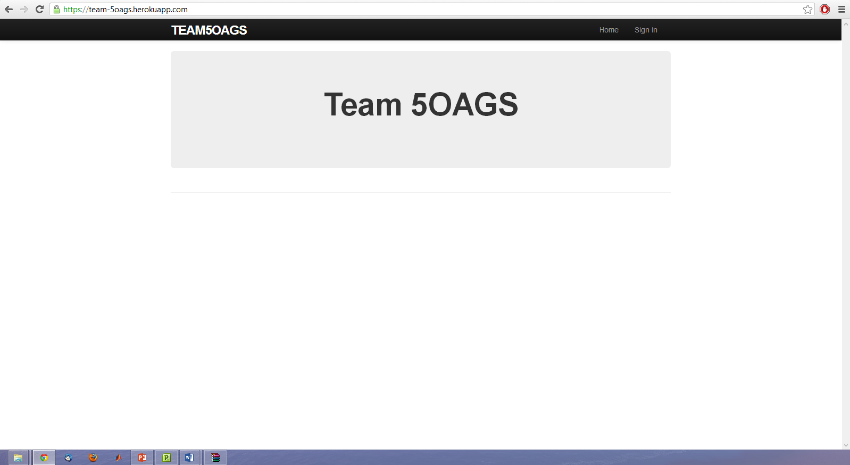

TEAM5OAGS Home Page Template

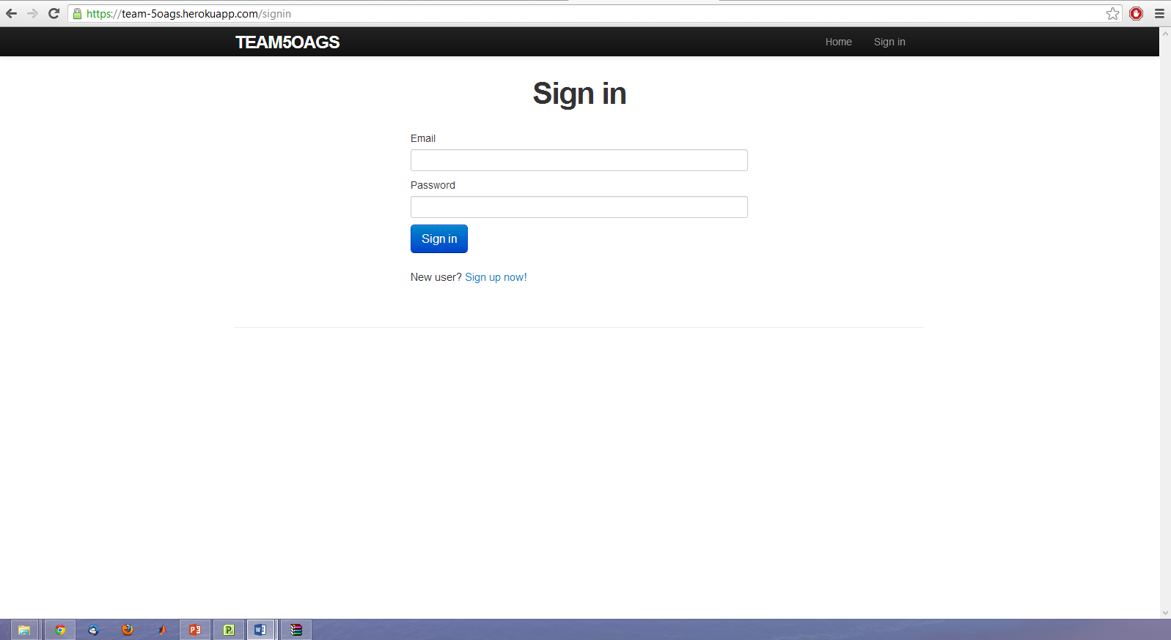

TEAM5OAGS Login Page Template

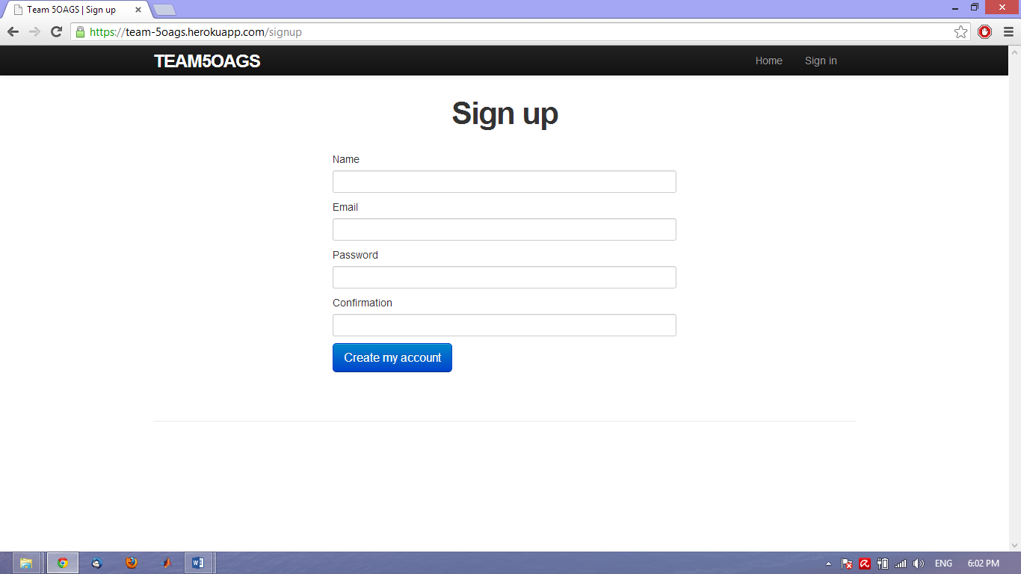

TEAM5OAGS Signup Page